DATE 19/08/2024

**IAM PRATICAL…** **ANIKET THORAT**

1.

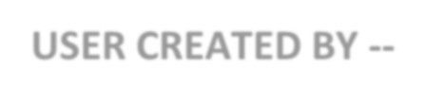

USER CREATED BY --

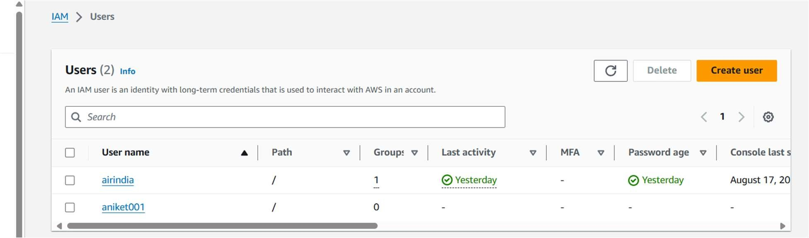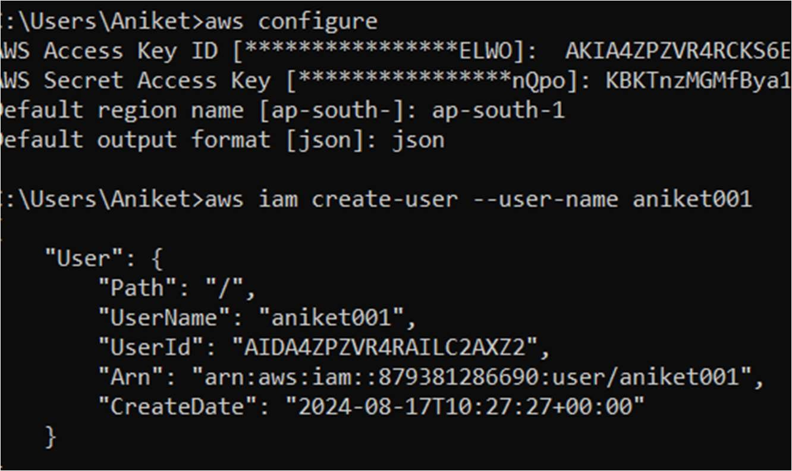

3.

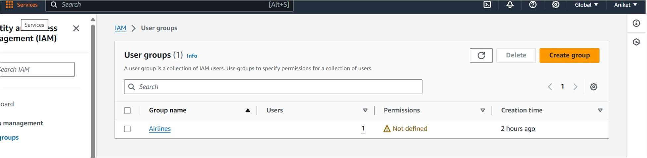

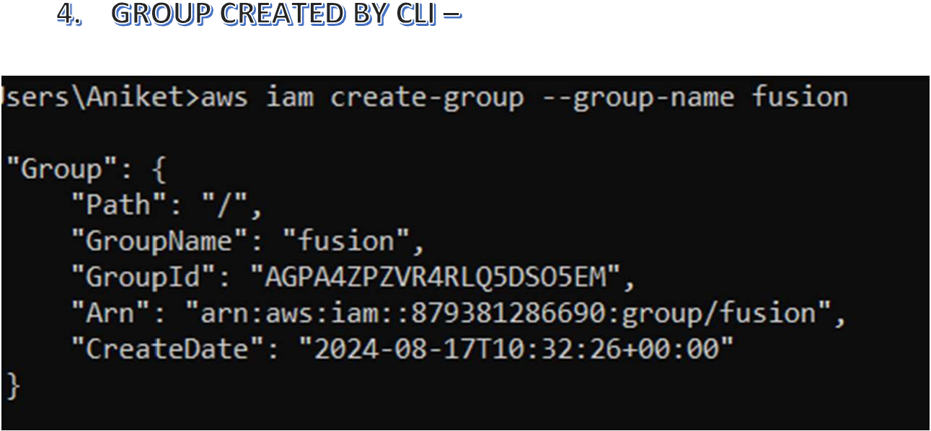

# 5. MFA FOR ROOT USER --

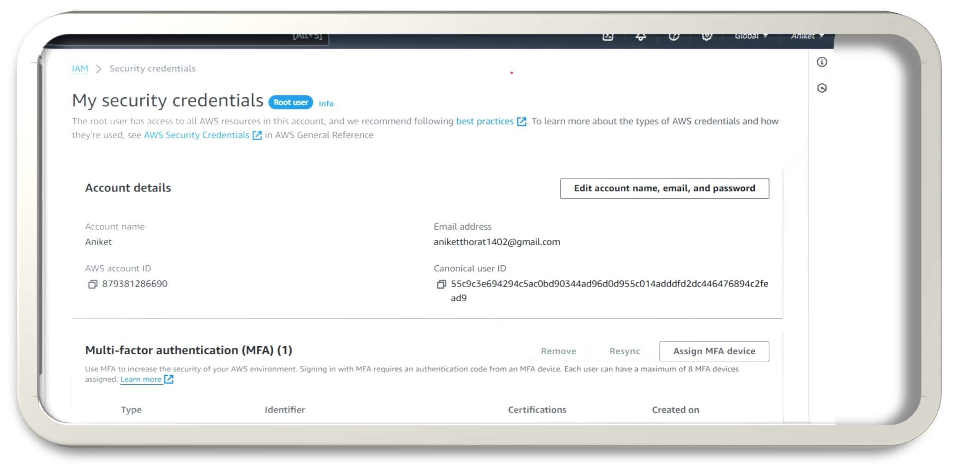

# ATTATCHED ROLE TO EC2 INSTANCE --

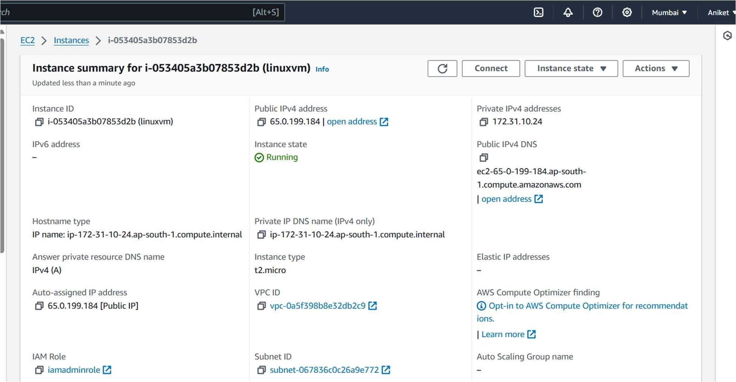

# ATTACHED ROLE , ACCESS KEY AND SECRET ACCESS KEY TO INSTANCE--

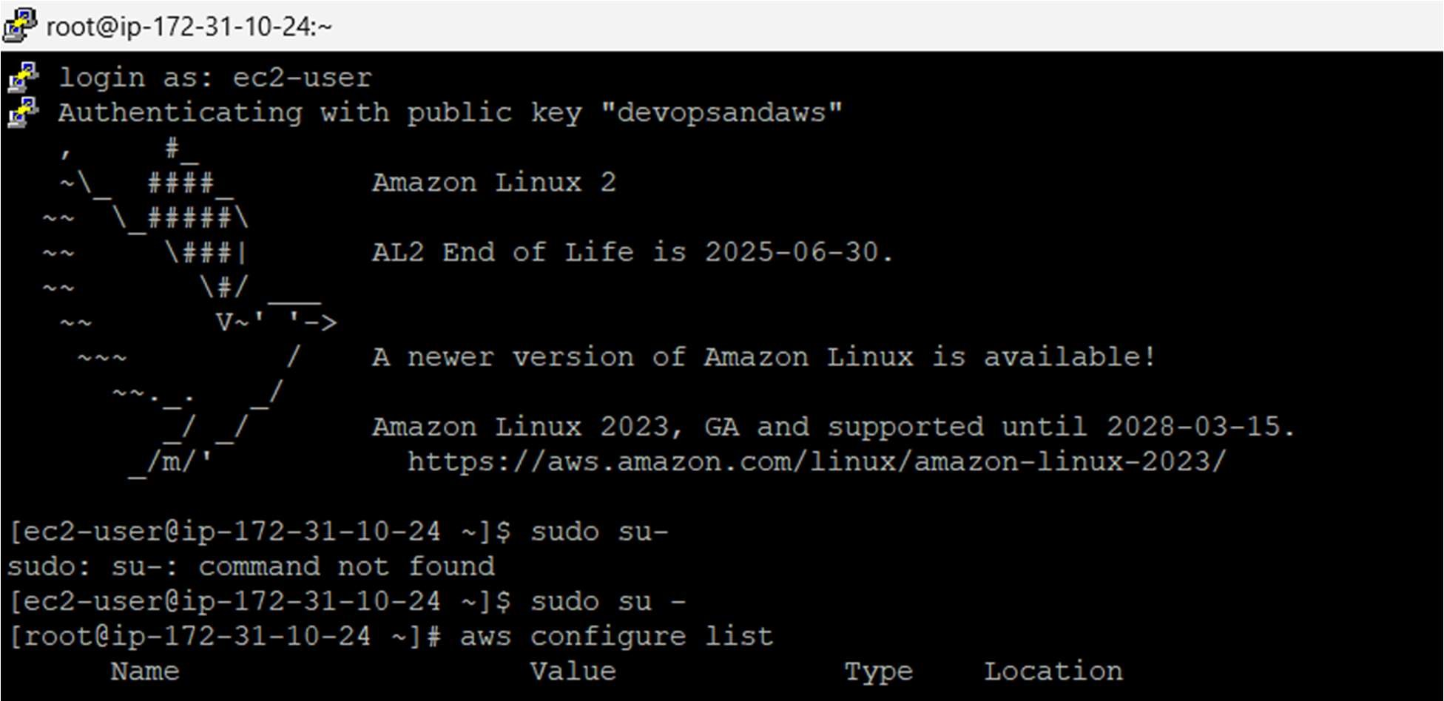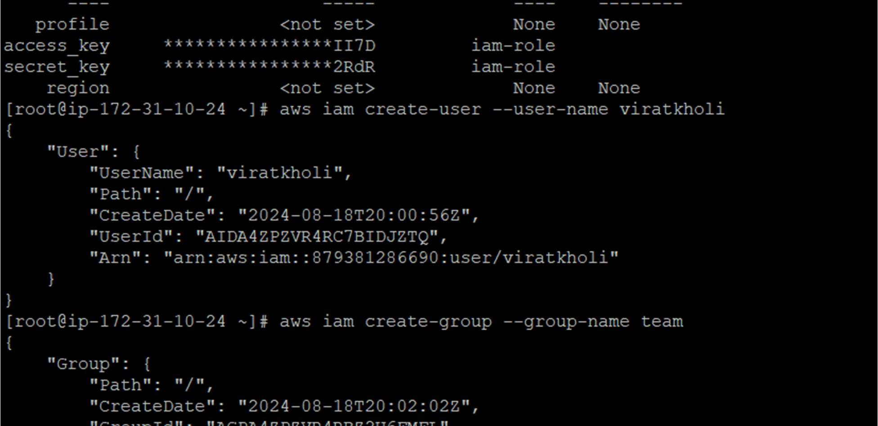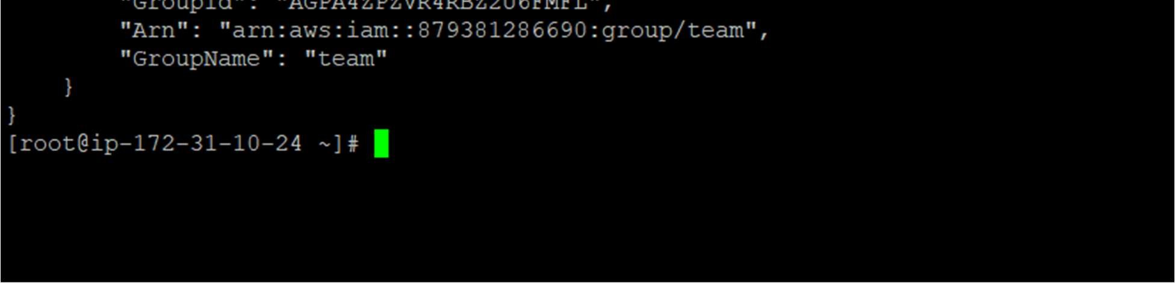

# LINUX EC2 INSTANCE CREATED IN MUMBAI REGION--

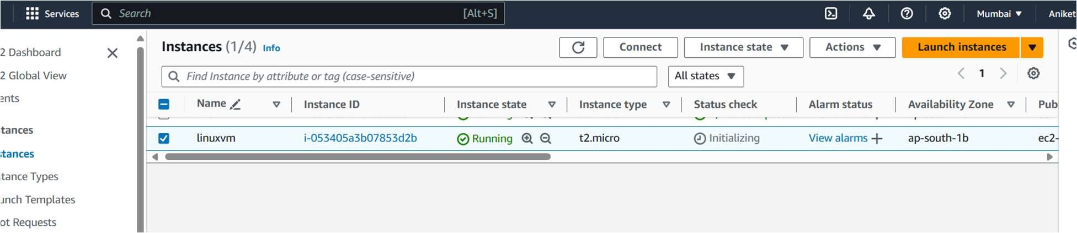

# 9. BUDGET, BILLING ALARM SETUP--

